**Practical 9:**

Functional Point Analysis (FPA) is a software measurement technique used to assess the size and complexity of a software system based on its functionality.

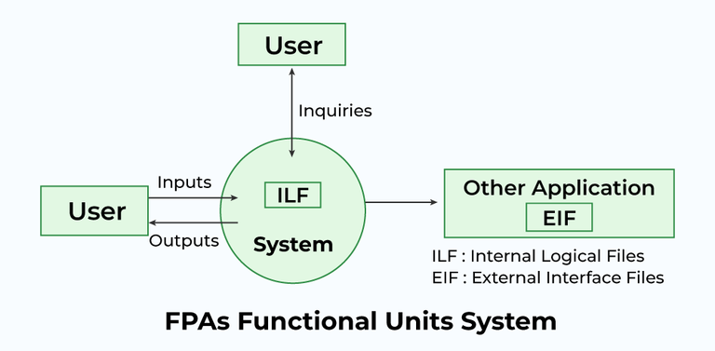

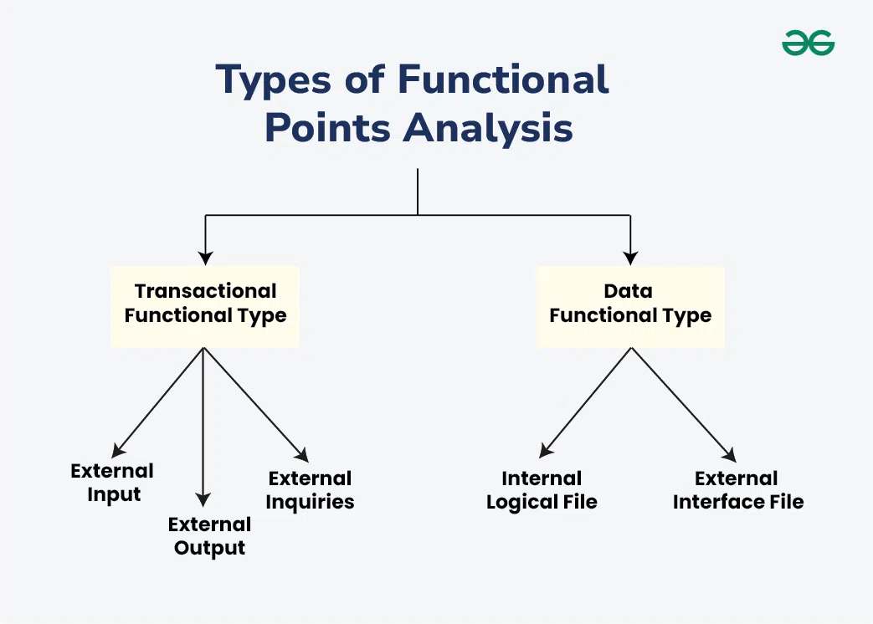

**Types of FP Attributes or Information Domain Characteristics**

| **Measurement Parameters** | **Examples** |
| --- | --- |
| Number of External Inputs (EI) | Input screen and tables |
| Number of External Output (EO) | Output screens and reports |
| Number of external inquiries (EQ) | Prompts and interrupts |
| Number of internal files (ILF) | Databases and directories |
| Number of external interfaces (EIF) | Shared databases and shared routines |

**Weights of 5 Functional Point Attributes**

| **Measurement Parameter** | **Low** | **Average** | **High** |
| --- | --- | --- | --- |
| Number of external inputs (EI) | 3 | 4 | 6 |
| Number of external outputs (EO) | 4 | 5 | 7 |
| Number of external inquiries (EQ) | 3 | 4 | 6 |
| Number of internal files (ILF) | 7 | 10 | 15 |
| Number of External Interfaces (EIF) | 5 | 7 | 10 |

Functional Complexities help us in finding the corresponding weights, which results in finding the Unadjusted Functional point (UFp) of the Subsystem. Consider the complexity as average for all cases. Below-mentioned is the way how to compute FP.

| **Measurement Parameter** | **Count** |  | **Weighing Factor** | | |
| --- | --- | --- | --- | --- | --- |
| Total_Count | **Simple** | **Average** | **Complex** |
| Number of external inputs (EI) | 32 | 32*4=128 | 3 | 4 | 6 |
| Number of external outputs (EO) | 60 | 60*5=300 | 4 | 5 | 7 |
| Number of external inquiries (EQ) | 24 | 24*4=96 | 3 | 4 | 6 |
| Number of internal files (ILF) | 8 | 8*10=80 | 7 | 10 | 15 |
| Number of external interfaces (EIF) | 2 | 2*7=14 | 5 | 7 | 10 |
| Algorithms used Count total → |  | 618 |  |  |  |

From the above tables, Functional Point is calculated with the following formula

*FP = Count-Total * [0.65 + 0.01 * ⅀****(fi)****]*

*= Count * CAF*

Here, the **count-total** is taken from the chart.

*CAF = [0.65 + 0.01 * ⅀****(fi)****]*

1. ⅀**(fi) =**sum of all 14 questions and it also shows the complexity factor – CAF.
2. CAF varies from 0.65 to 1.35 and ⅀**(fi)** ranges from 0 to 70.
3. When ⅀**(fi)** = 0, CAF = 0.65 and when ⅀**(fi)** = 70, CAF = 0.65 + (0.01*70) = 0.65 + 0.7 = 1.35